My photo
…CONFIDENTIAL…

This is my
Healthcare Passport
For children and young people with a disability, special or additional needs visiting a healthcare provider

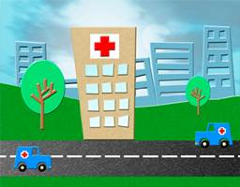

My name is:

If I have to visit a healthcare provider this book needs to go with me, it gives staff important information about me.

This passport needs to stay with me.

Things you must know about me
Things that are important to me
My likes and dislikes

Nursing and medical staff please look at my passport before you do any interventions with me.

This passport belongs to me. Please return it when I go home.

Things you must know about me

Name:

Likes to be known as:
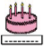

Date of Birth:

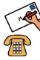
Address:

Tel No:
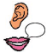
How to communicate with me:

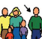
Contact person:

Relationship
e.g. Mum, Dad, Support Worker:

Address:

Tel No:
My support needs and who gives me the most support:
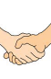

Date completedby
1

Things you must know about me
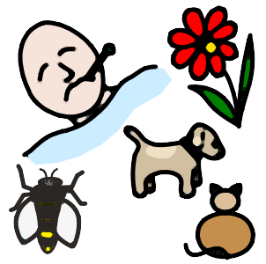
Allergies:
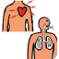
Heart/Breathing problems:
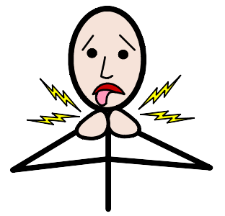
Risk of choking, difficulty with eating, drinking & swallowing:

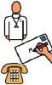
GP:

Address:

Tel No:
Other services/professionals involved with me (health, social care, community services, etc.):
Spiritual needs:
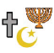
Religion:

Religious Needs:

Ethnicity:
What to do if I am anxious:
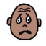

Date completedby
2

Things you must know about me
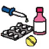
Current Medication

How I take medication: (Crushed tablets, injections, syrup…By Mouth, Gastrostomy/ naso-gastric tube)

Decisions about my treatment (Consent) (I may need support to make decisions about my care)
My medical history (operations and illnesses/ conditions that I have had) and treatment plan:
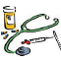
Medical Interventions: (How to take my blood, weigh me, etc.)

Date completedby
3

Things that are important to me
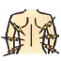
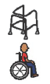
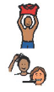
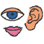
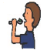
How you know I am in pain:
Moving around: (Posture in bed, walking aids, transfers, hoisting)
Personal care: (Dressing, washing, etc)
Seeing/Hearing: (Problems with sight or hearing)
How I eat: (Food cut up, help with eating, consistency of food/ Gastrostomy )

Date completedby
4

Things that are important to me
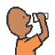
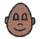
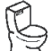
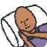
How I keep safe: (Bed rails, support with challenging behaviour)
How I use the toilet: (Continence aids, help to get to the toilet)
Sleeping: (Sleep pattern/routine)
Risk of choking, Dysphagia: (eating, drinking & swallowing)
How I drink: (Drink small amounts, thickened fluids)

Date completedby
5

My likes and dislikes
Likes: for example - what makes me happy, things I like to do
i.e. watching TV, reading, music, routines.

Dislikes: for example - don’t shout, food I don’t like, physical touch
Things I like

Please do this:

Things I don’t like

Don’t do this:
☹
☺

Date completedby
5

7

Notes

This Healthcare Passport is based on original work by Gloucester Partnership NHS Trust, the South West London Hospital Access to Acute Group, and Addenbrooke’s Hospital.
Thank you to Scope’s Meldreth Manor Team, The Young People from Speaking Up Youth Parliament, pinpoint, The Learning Disability Partnership, and CUHFT /Cambridgeshire PCT staff who inputted into the redesign of this document. Widgit symbols used with kind permission.

Useful Websites:

www.contactafamily.org.uk

www.voiceability.org.uk

www.mencap.org.uk

www.easyhealth.org.uk

www.edcm.org.uk (every disabled child matters)

www.special-needs-kids.co.uk

http://www.pals.nhs.uk/ (Patient Advice and Liaison)

www.ncb.org.uk (council for disabled children)

www.pinpoint-cambs.org.uk (parent involvement and support)

FURTHER COPIES OF THIS HEALTHCARE PASSPORT CAN BE OBTAINED FROM:

http://www.pinpoint-cambs.org.uk/get-involved/staying-healthy/healthcare-appointments

