Need a Break? Why not try the Eddie’s Holiday Home on Heacham Beach?
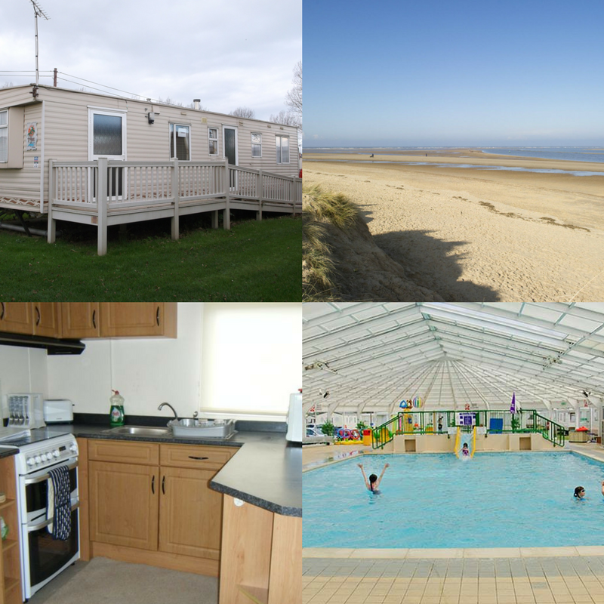
Bookings are now being taken for the 2018 season.

Prices start from £185!

Features:
- Fully Wheelchair Accessible with ramp, washroom facilities & spacious doorways and living area.
- Sleeps up to 6 people (two doubles and one twin)
- 5 minute walk to Heacham beach off the Norfolk coast.
- Includes access to Park Resorts facilities including swimming pool, arcade, entertainment, boathouse tavern and more!
Get away from it all with the Eddie’s Heacham Holiday Home.
For further details:
Please visit our website www.eddies.org.uk
Call us on 01223 883130 or email holiday@eddies.org.uk

