Pinpoint’s Annual Survey Report
2022-2023

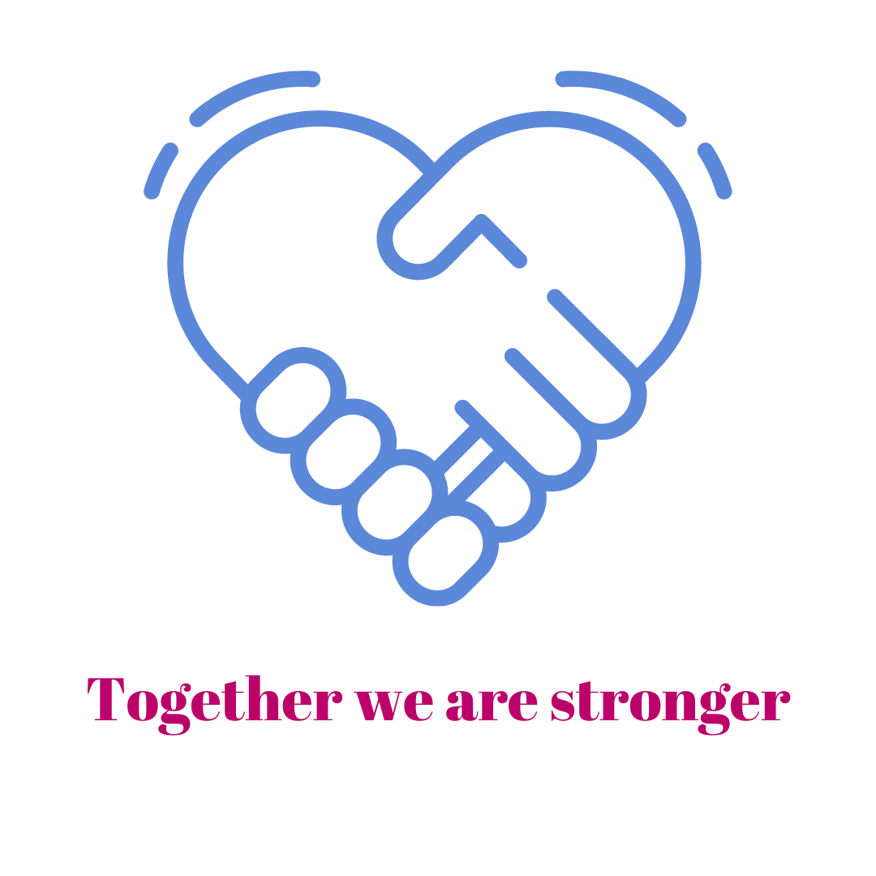
Summary Headlines
We were thrilled to have so many responses to our annual survey this year – 399, which is the biggest response we have ever had! This has been helped by us reaching out in different ways to hear from parent carers who we might otherwise not have heard from such as through the schools newsletter, social care engagement and through an Eventbrite email campaign to those who have previously come along to Pinpoint events.
Of our respondents, we might characterise two thirds to three quarters as being broadly positive about their experiences. This is a slight increase on last year. But, as before, there are concerns about the messages we are hearing from those who do not report satisfaction with their experiences of the SEND system in Cambridgeshire. Although most respondents have been broadly positive within the statistical information provided, the open text comments boxes give a much more negative view.
We appear to have heard from parents who are much earlier on in their journeys on this occasion which is positive as it supports the SEND transformation work to identify and support needs earlier.
There is an opportunity to look at how the positives can be used to address the concerns that the survey raises.
The issues raised by the survey have already been raised by Pinpoint over the last 12 months and are well known to the Local Authority and Health – there are no surprises and the areas identified by Pinpoint and this survey have been agreed as priorities: compliance, Preparing for Adulthood/transitions and improving SEN Support.

Key messages
- Free text commentary predominantly reflects frustrations and disappointments – it is rare that we get positive feedback from this section of the survey.
- The Statutory Assessment Team continues to cause worries in term of poor communication, timescales not being met and lack of knowledge of local schools and services from case workers.
- Health services are reported to be difficult to access and parents feel they are abandoned once their child is diagnosed.
- The thresholds for mental health services are too high and the waits are too long. This exacerbates poor school attendance for those who can’t attend due to poor mental health.
- Parent carers feel there are a lack of services post 16.
- Parent carers report that a lack of funding seems to drive a lack of services and SEND support.
- Parent and child blame continues to cause concern for parent carers who feel that the advice and support at Early Help stages is aimed at neurotypical children.
- Parent carers worry that professionals have a lack of training, knowledge and understanding. This is particularly the case in schools where the biggest concerns are around a lack of understanding of the needs of SEND children, masking and being considered ‘fine in school’ and a lack of awareness around school based trauma and absence.
- There is concern from parent carers around compliance and a lack of accountability in schools.
- Parent carers report an awareness that demand for services is high, but the system is complex and everything is a constant battle with the onus being on parent carers.

Review by questions
- Parental confidence about their engagement is stable – but there are still too many parents that believe they are not listened to, even in the statutory processes.

91% of parents report feeling they understand their children’s needs, with 44% feeling very confident.

22% is a high number to be reporting that professionals do not understand the needs of their children.
A small number, 9%, feel they, as parent carers, don’t understand their children’s needs – it’s not clear whether these are families reporting before or after assessments and this could be symptomatic of hearing from parent carers who are earlier in their SEND journey.

- Too many (we hear from) only get needs met by recourse to a dispute
12.5% of those who responded, report that EHCPs were only issued after a dispute.

- The legal requirements are either poorly understood and inconsistently implemented or are unknown and non-compliant in some cases.
Worryingly, 17% report they have had no involvement in SEND processes. A third are not satisfied about the ongoing monitoring and assessment of their children’s need.

- There is still work to be done to ensure all services are considered to perform well and work together around the child.
All services received a similar response in terms of those who felt that they received a good or very good service, with around three-quarters reporting it as being good or better.
The highest levels of satisfaction were recorded among education services with 80% feeling that support was good or very good.
Just under a quarter (of those we heard from) are only accessing part time education.
Those accessing health care also report good levels of satisfaction with 78% saying the support was good or very good.
The satisfaction with social care services is lower at 69% feeling well supported.
26% of those reporting still tells us that professionals do not appear to work together.

- When needs were identified 68% felt they had the help they needed meaning that around a third felt that they didn’t.

- Whilst there is still work to be done on the Local Offer, a new micro-site is eagerly anticipated, reporting is significantly more positive.
Just under half (43%) report that they do not have the information they need about services and support.
The Local Offer information is mostly of good quality and meets needs/expectations but 16% cannot fid the support they need and 56% found it difficult to find information

- Preparing for Adulthood remains a priority – it’s not universally known by the target group and what is known does not fully reflect an offer beyond that of education.
Preparing for Adulthood is not well-known – 11% report no awareness of it.
The confidence of those supporting young people 18yrs+ is poor with just over a quarter reporting no or very little, poor-quality information provided.
The information provided for those in the PfA group is predominantly about the education, social care and supported living offers. Most had no information about the financial or wills aspects of the PfA offer.

Question responses:
How well your views were taken into account to support your child/young person account when your child/young person's needs were identified?
75% positive responses – with 28% giving the highest praise.
21 % negative - with 4% reporting their views as being ignored.
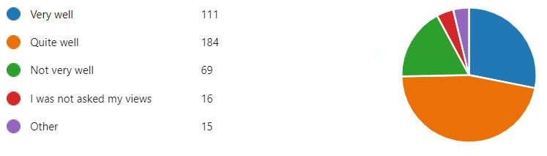

How well do you feel professionals who support your child/young person understand their identified needs?
82% positive responses - with 38% saying needs were well understood.
16% negative responses reporting needs were not well understood.
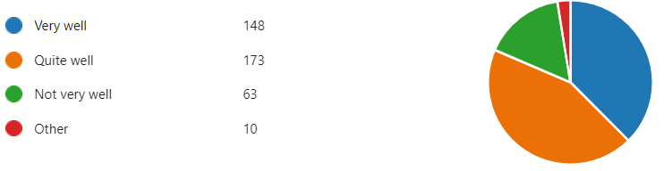
Support you have received from education services:
80% positive - with 34% reporting very good support.
15% negative – reporting support was not very good.
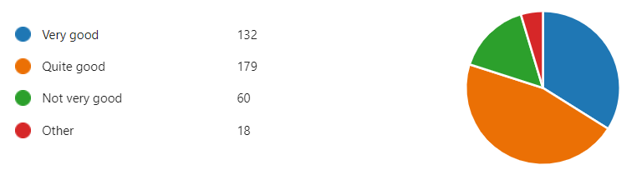
Support you have received from health services:
78% positive – with 33% being very good.
18% negative – reporting support was not very good.
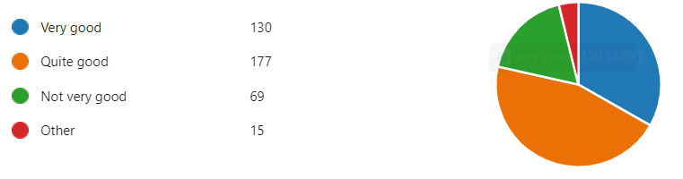

Support you have received from social services:
69% positive – with 28% being very good.
16% negative – reporting support was not very good.
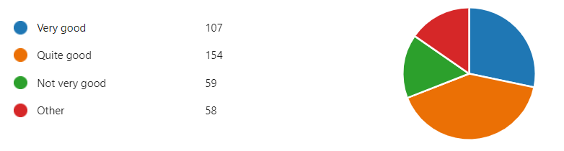
How well do you feel professionals who support your child/young person understand their identified needs?
79% positive – with 35% feeling well supported.
17% negative – reporting they were not well supported.
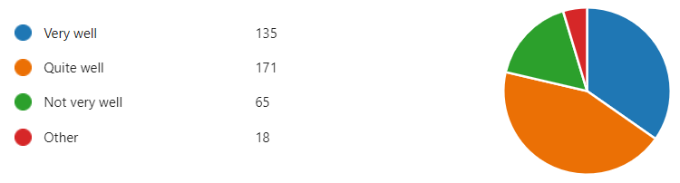
How well do you feel you understand you child/young person's needs?
44% are confident in their own understanding.
47% felt they understood the needs quite well.
8% reported that they felt they had inadequate understanding.
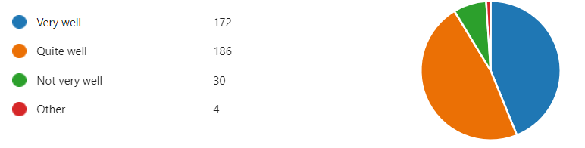

Once your child/young person's needs were identified, were you given any support to help you understand them?
68% felt they had the support they needed.
25% felt they were not given the support needed.
As a result of identifying your child/young person's needs, are they receiving any of the following support with their education?
27% of respondents reported children on SEN Support.
63% had EHCPs.
10% report no support.
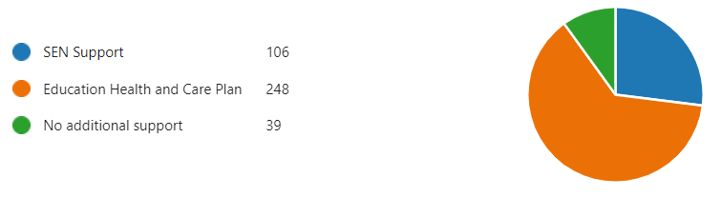
If your child/young person has an ECH Plan, was the Plan issued after:
14.5% had previously had statements.
35% had new assessments.
24% already had EHCPs.
9% had been through mediation.
4% tribunals
13.5% cited other triggers.
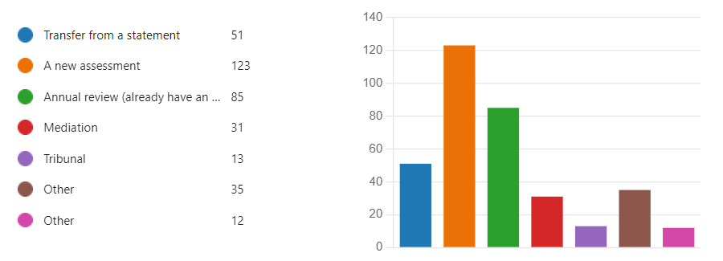
If your child/young person has SEN Support or an EHC Plan, does their education provider involve you in identifying and/or reviewing any support they receive?
78% say they are involved.
17% report no involvement.
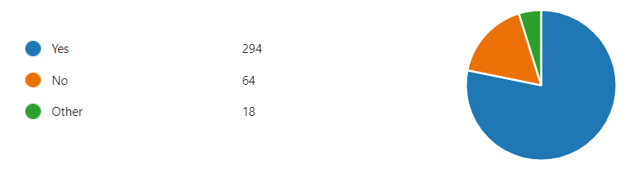
How satisfied are you with the ongoing monitoring and assessment of your child/young person's needs?
80% are positive – with 34% very satisfied.
17% are negative and not satisfied.
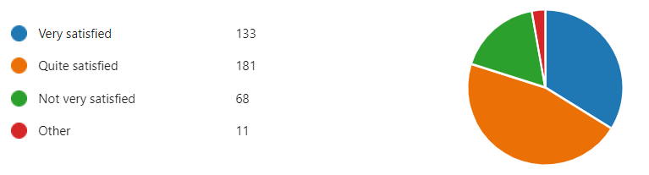

Did/do you find it challenging to ensure that your child/young person's needs are met?
44% report it was not challenging – with 9% reporting the smoothest experience
57% had a more difficult experience with 23% reporting it as very challenging
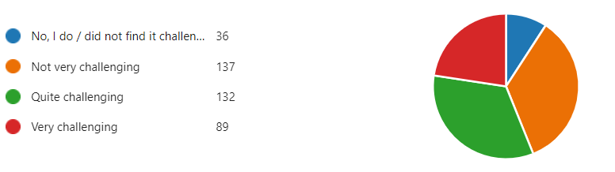
How well do services and professionals work together to support your child/young person?
73% are positive – with 30% reporting the most satisfaction.
22% are negative reporting they do not feel there is joint working.
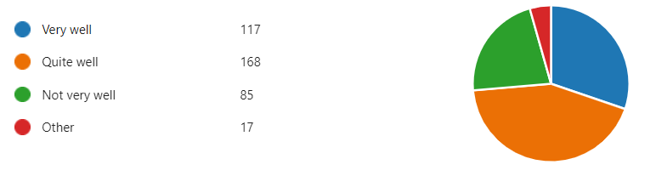

How easy do you find it to get the information about what services are available and what they do?
56% are positive- with 21% reporting it was easy.
43% are negative – with 11% reporting it is very difficult.
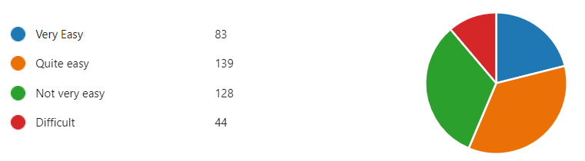
If you have used the 0-25 SEND Local Offer, how easy did you find it? Please choose the most appropriate statement.
84% were positive – with 28% reporting it was easy.
16% reported they could not find what they were looking for.
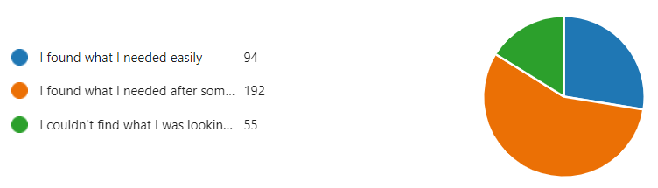
If you've used the Local Offer, how would you rate the information?
89% were positive – with 26% reporting what they found was very good.
10% were negative – reporting it was not very good.
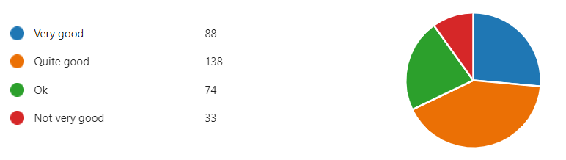
If your young person is older than 14, what has been your experience of the support for Preparing for Adulthood?
23% reported it as very good.
38% reported it as good.
20% reported it as ok.
9% reported it as not good.
11% had not heard of preparing for adulthood.
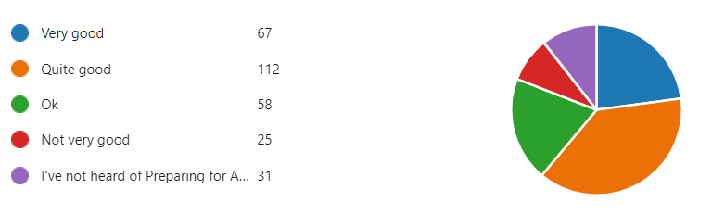
If you have a young person over 18 years, how well informed do you feel about how you can support them?
23% reported they were very well informed.
49% reported being quite well informed.
28% reported negatively – with 9% reporting they were not informed at all.
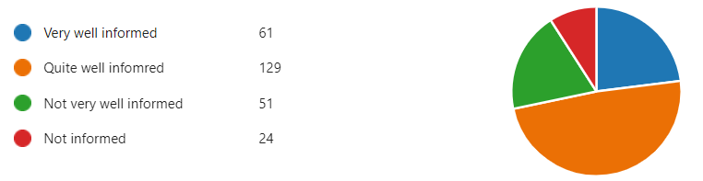
If your young person is 16 and older, have you/they received information on the following:
37% had information about further education options.
29% had information about adult social care options.
26% had information about independent living options.
5% had information about Wills and trusts.
3% had information about benefits and finance.
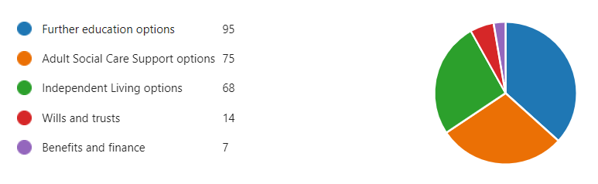

If your young person is older than 18, how well supported are they by Adult Social Care?
70% reported being well supported, with 27% feeling very well supported.
14% reported it as not being applicable.
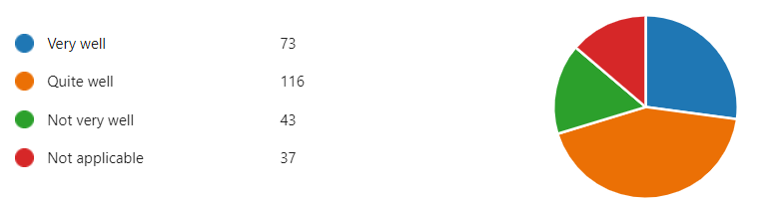
Those completing the survey described their role in the following ways:
85% Parent carer
6% Kinship carer
5% foster parents
3% supportive relatives
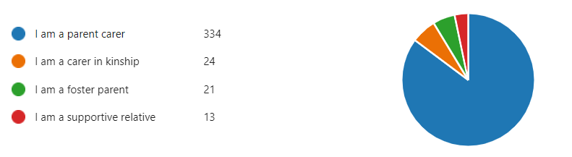
Some of the free text comments:
- What services? i.e. their don't appear to be any, if it wasn't for her specialist provision we would have no help and once she leaves education it appears that's it, she/we are on our own.
- The school don't seem interested in a diagnosis because "they don't get any more money"
- Felt a bit abandoned after diagnosis and relied on me to find out things and push for changes
- Despite having an EHCP, my son has been ‘worked out’ of his education by using an illegal permanent exclusion - and as far as I can tell, there is no penalty to the school for this, but my son is completely socially isolated - but wants to see friends and wants to go to school.
- As a parent I found primary worked with us to support my child. Secondary did not at all and the treatment has caused long term damage to my child and us as a family. Services are chronically underfunded and it is a constant battle.
- As he was 'fine in school' he was reused an assessment via NHS and we paid privately. Why do we need to wait for our young people to fail before we help them
- Listen to us!
- Request to take child on adult violence seriously and encourage the taboo on this topic to be broken. This is ultimately a safeguarding issue and seeing only children as victims means you don't appreciate that they will be victims if you don't support adults around them, whilst the cycle of violence risks continuing.
- School trauma is a huge problem that someone should be taking seriously and investigating
- The level of support seems hit and miss, some SENDCos are great, others seem to be doing the role as a tick box exercise.
- It's just not good enough across the board. The absolute battle to get the right support is terrifying and draining on parents who very often have such little resilience left
- My son has been let down. For years I have raised concerns and the school system, GP has refused further support. A private assessment yesterday has confirmed I am correct. My son needs support. Your services are failing children.
- Communicate more. Communicate more.
- Long waits for mental health support are a huge problem, can’t access education due to mental health, waiting well over a year for support. Institutional parent blame is a problem with teaching staff in particular (though we haven’t yet experienced parent blame from SEN services staff, it’s the staff working with children day to day who have little understanding of autism and quickly resort to parent blame and child blame. Staff do not understand that autistic children, even when highly verbal, can need someone to advocate for them. Outdated and ableist views from teaching staff (though again SEN services staff have been more understanding of needs so far). START is like a black box, it would be so helpful if they acknowledged receipt of documents and updated us on progress during application for EHCP.
- My biggest sources of guidance and support have been Pinpoint, SENDIASS and other parents (not the schools, LA etc!). It is a constant struggle and I'm still unearthing info I feel should be readily available. If parents / carers don't have the time, money (for private reports) and writing skills I'm fortunate to have, and a strong constitution to keep going (!), I don't know how they get anywhere. So many children are still being failed by the system.

About the respondents
Location
14% Fenland
21% East Cambridgeshire
24% South Cambridgeshire
23% Huntingdonshire
19% Cambridge City

Gender of child
54% male
43% female
3% non-binary

Age of child
8% under 5
51% primary age
27% secondary age
12% 16 – 18 years
2% 19 – 25 years

Ethnicity
47% White British
15% White European
14% White other
3% Mixed Ethnicity
6% Asian
4% Asian British
4% Black British
2% Black African
2.5% Black Other
2% Arab
1% Other
0% White Gypsy or Irish Traveller

Current placement by school / institution
10% Nursery / pre-school
36.5% Mainstream primary
19% mainstream Secondary
9.5% Special
13% cabin
1% Pupil referral unit
5.5% independent school
3% independent special
2% Out of county placement
2% Elective home education
3% Out of school/not receiving education
2% Further/post 16 institution
1.5% finished school

Timetabled provision
77% are in a full-time timetable.
23% are on a part-time timetable.

Need ranked by times reported by those completing the survey
Autistic Spectrum Disorder
Social and Emotional Mental Health Needs
My child/young person's needs have not been identified yet
Attention Deficit Hyperactivity Disorder / Attention Deficit Disorder
Speech and language impairment
Sensory Processing Disorder
Moderate learning difficulties
Specific Learning Difficulty e.g., dyslexia, dyspraxia, dyscalculia, dysgraphia
Global Developmental Delay
On the Early Help Pathway
Severe Learning Difficulties
Visual impairment
Medical Needs / Complex Health Needs Medical Needs / Complex Health Needs
Physical Disability
Hearing Impairment

