Preparing for Adulthood (PfA) SEND in Cambridgeshire FAQs for Parent Carers
This guide supports parent carers of children and young people with SEND in Cambridgeshire. It aligns with the SEND Code of Practice and Cambridgeshire EHCP and/or Annual Review expectations.

What is Preparing for Adulthood (PfA)?
PfA is the planning and support process that helps young people with SEND move from childhood into adult life — concentrating on education/training or work, independent living, friendships and community participation, and good health. It’s part of the SEND Code of Practice and should start early in secondary school.

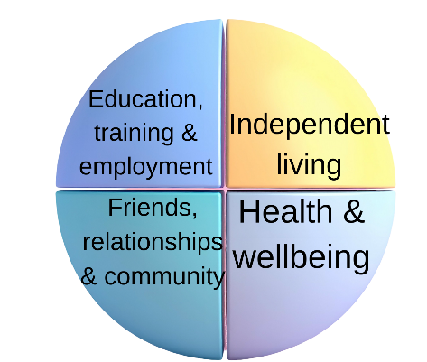

When should PfA planning begin?
Formal PfA planning typically starts at Year 9 (around age 14) — especially through EHCP Annual Reviews — but preparation really begins long before through everyday opportunities to develop independence skills.

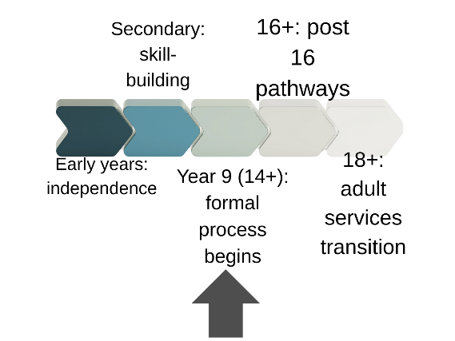

What are the PfA outcomes?
The four outcome areas are:
• Education, training & employment
• Independent living skills
• Friends, relationships & community inclusion
• Health & wellbeing
All planning should reference these in goals and outcomes.

How does PfA link with an Education Health and Care Plan (EHCP)?
PfA should be embedded into your child’s EHCP outcomes and discussed at Annual Reviews from Year 9 onwards. The EHCP is the legal plan that helps ensure pathways into adulthood are supported.

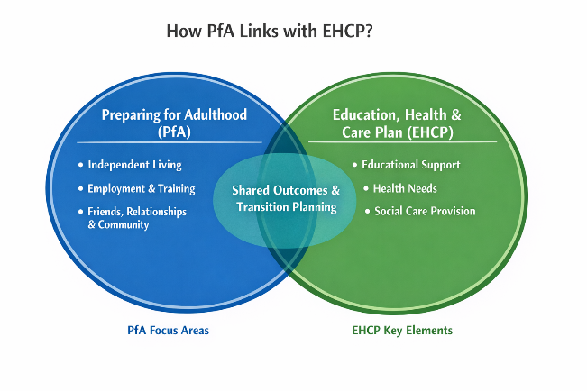

What should we be doing before and during Annual Reviews?
Before: Talk with your child about what they want in adult life — employment, further education, living arrangements.
During: Use a PfA checklist to help ensure skills building and support needs under education, employment, independence, community, and health are discussed.

When must PfA be included in EHCP reviews?
From Year 9 onwards (age 14+), Preparing for Adulthood must be a key focus of EHCP Annual Reviews in Cambridgeshire.

Who is responsible for PfA planning?
Schools, colleges, the local authority, health services and families all contribute, with the young person at the centre.

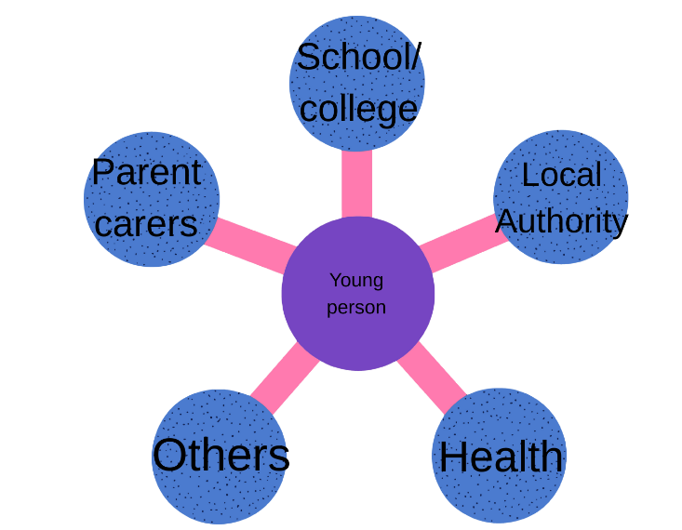

What are post 16 options for education or training?
Options include:
• College courses (academic or vocational)
• Supported Internships or traineeships
• Employment with support
• Volunteering and adult learning programmes
Check College SEND support, vocational pathways, and careers advice early.

What employment support is available locally
Cambridgeshire offers local careers guidance, supported internships, work experience opportunities, and employer links — often through schools, colleges, and parent-carer groups. Pinpoint provides information and ideas about local employment routes.
What about independent living and adult social care?
PfA includes developing life skills (money management, travel training, home living skills) early on and, when appropriate, adult social care assessments as the young person approaches 18. Those transitioning to adult services may need a separate needs assessment because eligibility rules change.
How does health transition work?
Young people with learning disabilities are entitled to an annual health check from age 14–18, helping prepare them for adult health services and support ongoing wellbeing.
Do parent carers stop being involved once a child turns 18?
No — legal responsibility for decisions usually passes to the young person at 18, but you can support them, help with decision-making, and — with consent — be part of meetings, planning, and advocacy. Formal advocates can also be arranged where needed.
Where can we find local help and information?
• SEND Information Advice & Support Service (SENDIASS) — impartial help with education, health, care issues.
• Pinpoint parent carer forum — PfA guides, checklists, support groups.
• Cambridgeshire Local Offer (Preparing for Adult Life pages) — employment, housing, transport, health.
• Caring Together — carer support and wellbeing resources.

 | 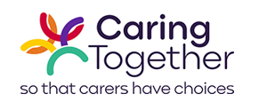
 | 
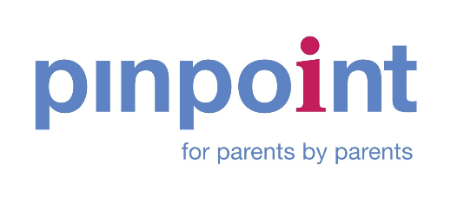
What if we disagree with decisions about PfA or an EHCP?
You are entitled to appeal decisions about EHCPs and PfA outcomes through dispute resolution, mediation, or the SEND Tribunal — and SENDIASS can support you with this.
Where can we find PfA checklists and guides?
Parent guides, checklists for reviews, and PfA planning documents are available through Cambridgeshire Local Offer and Pinpoint. These help you track progress in key areas.


Year 9 EHCP Annual Review – Preparing for Adulthood Checklist (Cambridgeshire)
This checklist reflects what Cambridgeshire expects to be covered in a Year 9 (and later) EHCP Annual Review. It can be used alongside the Local Authority Annual Review paperwork.

Education, Training and Employment (Section E outcomes)
  - Are aspirations for adult life clearly recorded in Section A?
  - Do Section E outcomes include preparation for post-16 education, training or employment?
  - Is careers advice, work experience or vocational learning identified?
  - Are outcomes specific, measurable and focused on long-term independence?

Independent Living (Sections A, E and F)
  - Does the EHCP describe current independence skills and future goals?
  - Are travel training, money skills or daily living skills included in outcomes?
  - Is there discussion about future housing or adult social care pathways?
  - Is preparation for adult services noted where appropriate?

Friends, Relationships and Community (Sections A and E)
  - Does the plan reflect what matters to the young person socially?
  - Are outcomes included for friendships, community access or activities?
  - Is support for communication or social interaction identified?

Health and Wellbeing (Sections C, E and G)
  - Are health needs clearly updated and accurate?
  - Is transition from children’s to adult health services discussed?
  - Is preparation for managing appointments or medication considered?

Review Actions and Next Steps
  - Are actions clearly recorded with named responsibilities?
  - Is there clarity on what the school/college will do and what the LA will do?
  - Is the next review date agreed and recorded?

Questions to Ask at a Year 9 (or later) EHCP Annual Review

Questions for the School or College
  - How is Preparing for Adulthood built into everyday learning?
  - What opportunities will my child have to develop independence skills?
  - What careers education or work-related learning is planned?
  - How will progress towards PfA outcomes be measured and reviewed?

Questions for the Local Authority or SEND Case Officer
  - How will the EHCP change to reflect Preparing for Adulthood?
  - What post-16 and post-18 pathways are available locally?
  - When should adult social care assessments be considered?
  - Who will coordinate transition planning as my child gets older?

One-Page Preparing for Adulthood Checklist – For Meetings

Area | Checked / Notes
Aspirations for adult life discussed
PfA outcomes included in EHCP (Section E)
Post-16 / post-18 options discussed
Independence skills identified
Community and friendships considered
Health transition discussed
Actions agreed and responsibilities clear
Next review date agreed
You may wish to bring this page to the meeting and use it to record notes or agreed actions.

